**The Federal Records & Information Management Forum**

**MARCH 16, 2015**

**RIM FORUM**

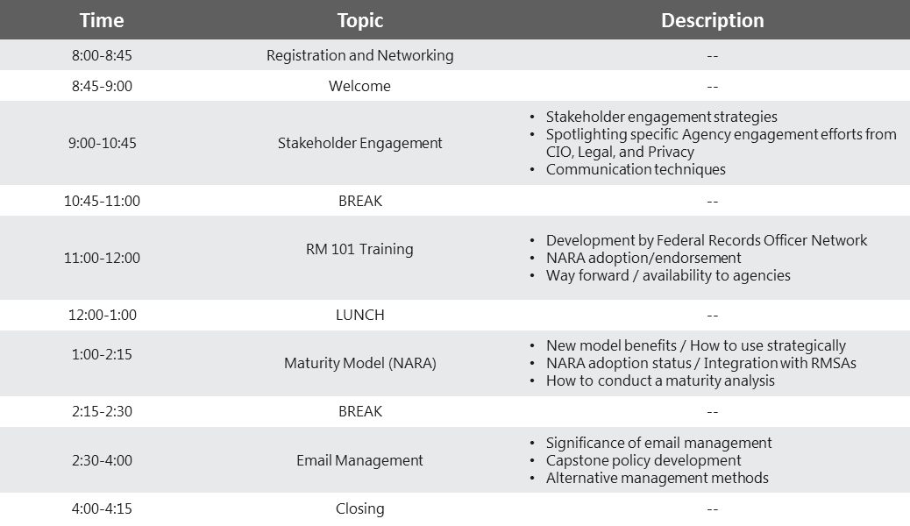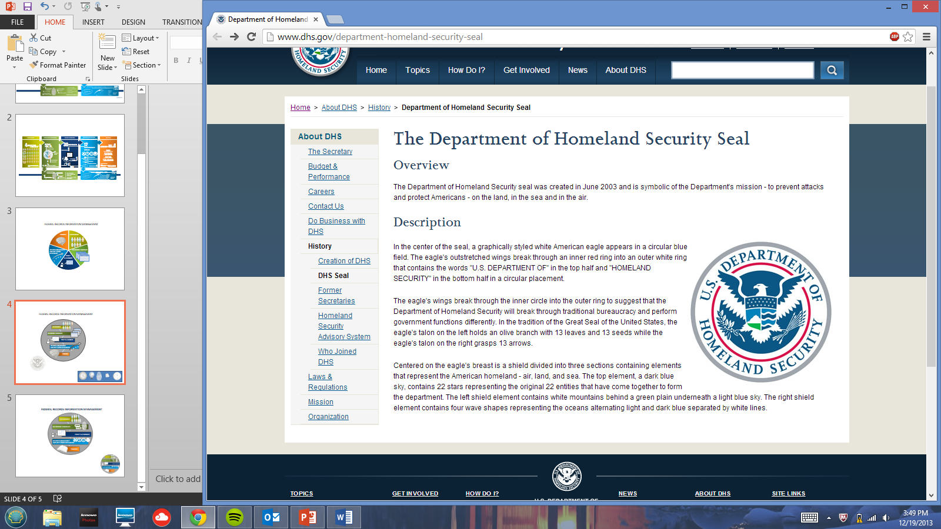

**Registration closes Wednesday, March 11th.**

**To submit your registration form:**

***dhsrecordsmanagement@hq.dhs.gov***

**\*Due to limited seating, registration is limited to Federal Staff only and is on a first-come, first-served basis.**

**I am planning to attend:**

(Please choose one from below.)

**Full day  Morning only  Afternoon Only**

**NAME (Last, First, MI):** Click here to enter text.

**TITLE:** Click here to enter text.

**AGENCY/OFFICE:** Click here to enter text.

**E-MAIL:** Click here to enter text.

**PHONE:** Click here to enter text.

**REGISTRATION FORM\***

Homeland Security